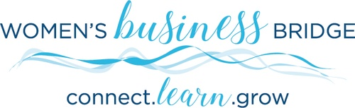

Women’s Business Bridge (WBB) introduces Community Outreach Partners

September 1, 2019- Women’s Business Bridge, a program of the Greater Stillwater Chamber of Commerce, is excited to partner with 2 local non-profit organizations. WBB has identified Community Outreach as a dedicated initiative for the organization this year. The non-profits were selected as a result of nominations by members. Our goal is to help and support these partners by providing opportunities to share their mission and initiatives to help advance their organizations.

The partners chosen are Safe Haven Foster Shoppe and Women United, an affiliate program of the United Way of Washington County East.

Safe Haven Foster Shoppe (https://safehavenfostershoppe.org/) is a non-profit organization that provides essentials to children in foster care primarily north and east of the Twin Cities and Western Wisconsin WI (Polk and St. Croix counties). Safe Haven Foster Shoppe’s goal is to provide placement items for foster children and alleviate the financial burden on foster homes by soliciting, collecting, and packaging placement packs for distribution through a network of county agencies and directly with foster homes.

Women UNITED (http://www.uwwce.org/women-united) works with partnering agencies including: Valley Outreach, Tubman, Solid Ground and St. Andrew’s Resource Center, to provide support to low-income, single mothers and parents in need.

For more information visit the Chamber website or call the Chamber office at 651-439-4001.

